**Network Design Proposal for Company**

### A COURSE PROJECT REPORT

By

# STUDENT NAME: PARTH MOGHEKAR

# **REG NO.: RA1911003010368**

Under the guidance of

**DR M. KANCHANA**

*In partial fulfilment for the Course*

of

### 18CSC302J - COMPUTER NETWORKS

in Department Name



# FACULTY OF ENGINEERING AND TECHNOLOGY

# SRM INSTITUTE OF SCIENCE AND TECHNOLOG

**SRM INSTITUTE OF SCIENCE AND TECHNOLOGY**

**(Under Section 3 of UGC Act, 1956)**

**BONAFIDE CERTIFICATE**

Certified that this project report " Network Design Proposal for Company" is the Bonafide work of Parth moghekar(RA1911003010368) who carried out

the project work under my supervision.

# SIGNATURE SIGNATURE

Subject Staff **Dr.E. Sasikala,**

## Designation Course Cordinator

**Department Associate Professor,**

SRM Institute of Science and Technology **Data Science and Business Systems** Potheri, SRM Nagar, Kattankulathur, SRM Institute of Science and Technology Tamil Nadu 603203 Potheri, SRM Nagar, Kattankulathur,

Tamil Nadu 603203

**Team No.22**

**Team Members : RA1911003010351 ,RA1911003010368**

**Network Design Proposal for Company**

The users of the network will be the 500 employees of Company. This is intended to be an

internal network accessible only by employees, not customers. The users

will require access from three different geographic locations: 1) the Headquarters Office 2) the

Production and Warehouse facility and 3) the Sales Office.

Network requirement

1. Network Topology diagram.

2. Identify the hardware required like routers, switches, access points (Cisco)

3. The network has to be segregated into different locations

4. TCP/IP Network design and IP address table.

5. Configurations and features which are required to be configured on the devices

REQUIREMENT SPECIFICATION

* + 1. **Hardware Requirements**

Processor : 2.4 GHz Clock Speed RAM : 1 GB

Hard Disk : 500 MB (Minimum free space)

* + 1. **Software Requirements**

Operating System : Windows 10 Platform: CISCO PACKET TRACER

# ACKNOWLEDGEMENT

We express our heartfelt thanks to our honorable **Vice Chancellor Dr. C. MUTHAMIZHCHELVAN**, for being the beacon in all our endeavors.

We would like to express my warmth of gratitude to our **Registrar Dr. S. Ponnusamy,** for his encouragement

We express our profound gratitude to our **Dean (College of Engineering and Technology) Dr. T. V.Gopal,** for bringing out novelty in all executions.

We would like to express my heartfelt thanks to Chairperson, School of Computing **Dr. Revathi Venkataraman,** for imparting confidence to complete my course project

We wish to express my sincere thanks to **Course Audit Professor Dr.M.LAKSHMI, Professor and Head, Data Science and Business Systems** and **Course Cordinator Dr.E. Sasikala, Associate Professor, Data Science and Business Systems** for their constant encouragement and support.

We are highly thankful to our Course project Internal guide DR M. Kanchanafor **her** assistance, timely suggestion and guidance throughout the duration of this course project.

We extend my gratitude to Dr. M. Pushpalathaand my Departmental colleagues for their Support.

Finally, we thank our parents and friends near and dear ones who directly and indirectly contributed to the successful completion of our project. Above all, I thank the almighty for showering his blessings on me to complete my Course project

# TABLE OF CONTENTS

**CHAPTERS CONTENTS PAGE NO.**

* + - 1. **ABSTRACT**
      2. **INTRODUCTION**
      3. **REQUIREMENT ANALYSIS**
      4. **ARCHITECTURE & DESIGN**
      5. **IMPLEMENTATION**
      6. **EXPERIMENT RESULTS & ANALYSIS**
         1. RESULTS
         2. RESULT ANALYSIS
         3. CONCLUSION & FUTURE WORK
      7. **REFERENCES**

**ABSTRACT**

This report describes Network Design for a Company. In this network topology the nodes (i.e., computers, switches, routers or other devices) are connected to a local area network (LAN) and network via links (twisted pair copper wire cable or optical fibre cable). We have used Cisco Packet Tracer for designing the network topology It’s a general design which can be implemented at any higher level to manage network system.

A network consists of three main components- the clients, servers, and circuits. The clients are the devices at the user end. The servers store data and/or software that the user can access, and the circuit is the system of connections between components of the network. The circuit provides the pathway through which signals travel, and can be comprised of both wired and wireless connections. In the case of the network design for the Company, for different jobs computers, cell phones, laptops, printers and tablets and connected. The servers store data, and are found in each of the LANs at the three sites.

**INTRODUCTION**

The users of the network will be the 500 employees of Company. This is intended to be an

internal network accessible only by employees, not customers. The users

will require access from three different geographic locations: 1) the Headquarters Office 2) the

Production and Warehouse facility and 3) the Sales Office.

**REQUIREMENT ANALYSIS**

In Network design for company, we have desktop Computer, laptops, smart phone. There is a data flow between the devices within the system. We have divided our network into 3 geographical segments the Headquarters Office, the Production and Warehouse facility and the Sales Office. We have also used SSH for security. Our network requirements include network devices like routers, switches, server.

In this project laptops, pc, tablet, phones, telephones, printers, routers, switches, hubs, wireless networks etc.

**COST OF NETWORK**

* **Cisco Switch**

16870 RUPEES Each

94089 RUPEES Cost of 7 Switch

* **Cisco Router**

24345 RUPEES Each

158070 RUPEES Cost of 5 Router

* **Cisco Server**

30108 RUPPES Each

90217 RUPEES Cost of 3 Server

* **Computer Cost**

9408 RUPEES Each

50907 RUPEES Cost of 7 Computer

**Laptop cost**

9000 rs each

18000 rs cost of 2 laptops

Tablet cost

5000rs each

5000rs cost of 1 tablet

Mobile cost

2000rs each

2000rs cost of 1 mobile

Printer

4000rs for 1 printer

Telephone

1000rs each

2000rs for 2 telephones

TOTAL COST =6,56,500.

**ARCHITECTURE & DESIGN**

The network design for this company has 3 geographical locations connected by fast ethernet

1) Headquarters Office

2) Production and Warehouse facility

3) the Sales Office.

1) Headquarters Office

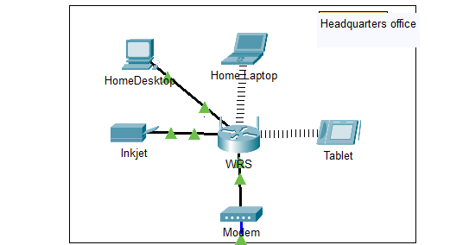

Headquarters office consists of 1 pc, 1 laptop, 1 tablet, 1 printer connected to a router

2) Production and Warehouse facility

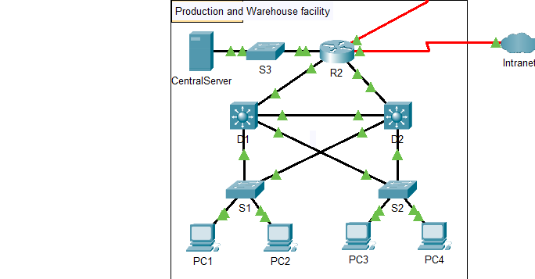

Production and Warehouse facility consists of server, four pc, three switch, one router and two multilayer switches

3) Sales Office.

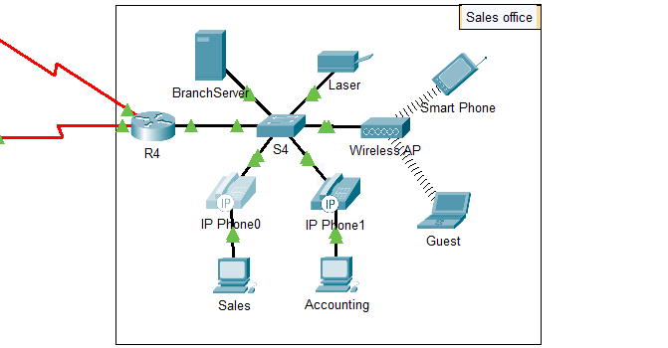

The sales office consists of 1 server, 2 pcs, 2 telephones, 1 laptop, 1 smartphone, 1 switch, 1 multilayer switch, 1 server, 1 router.

COMPANY NETWORK

The networks consist of end devices, routers, switches and hub

These connected by straight copper wire and serial DTE.

This network consists of 15 end devises,

3 routers and 5 switches

**IMPLEMENTATION**

The users of the network will be the 500 employees of Company. This is intended to be an

internal network accessible only by employees, not customers. The users

will require access from three different geographic locations: 1) the Headquarters Office 2) the

Production and Warehouse facility and 3) the Sales Office.

In this network all devises are connected to each other by wired and wireless connections

The massage is successfully passed through the internet and wired connection network to our desired location

Eg, the massage is successfully sent from sales department to the pc.

**DEFINITIONS**

* **DHCP**

The Dynamic Host Configuration Protocol (DHCP) is a network management protocol used on UDP/IP networks whereby a DHCP server dynamically assigns an IP address and other network configuration parameters to each device on a network so they can communicate with other IP networks.

* **DNS**

The Domain Name System is a hierarchical and decentralized naming system for computers, services, or other resources connected to the Internet or a private network.

* **SUBNETTING**

A subnetwork or subnet is a logical subdivision of an IP network. The practice of dividing a network into two or more networks is called subnetting.

* **HTTPS**

Hypertext Transfer Protocol Secure is an extension of the Hypertext Transfer Protocol. It is used for secure communication over a computer network and is widely used on the Internet. Hypertext Transfer Protocol Secure is an extension of the Hypertext Transfer Protocol. It is used for secure communication over a computer network and is widely used on the Internet.

* **SSH**

Secure Shell is a cryptographic network protocol for operating network services securely over an unsecured network.

* **SMTP**

The Simple Mail Transfer Protocol is a communication protocol for electronic mail transmission.

**FTP**

The File Transfer Protocol is a standard network protocol used for the transfer of computer files between a client and server on a computer network.

**WIFI**

Wi-Fi is the name of a wireless networking technology that uses radio waves to provide wireless high-speed Internet and network connections.

**EXPERIMENT RESULTS & ANALYSIS**

**RESULT:-**

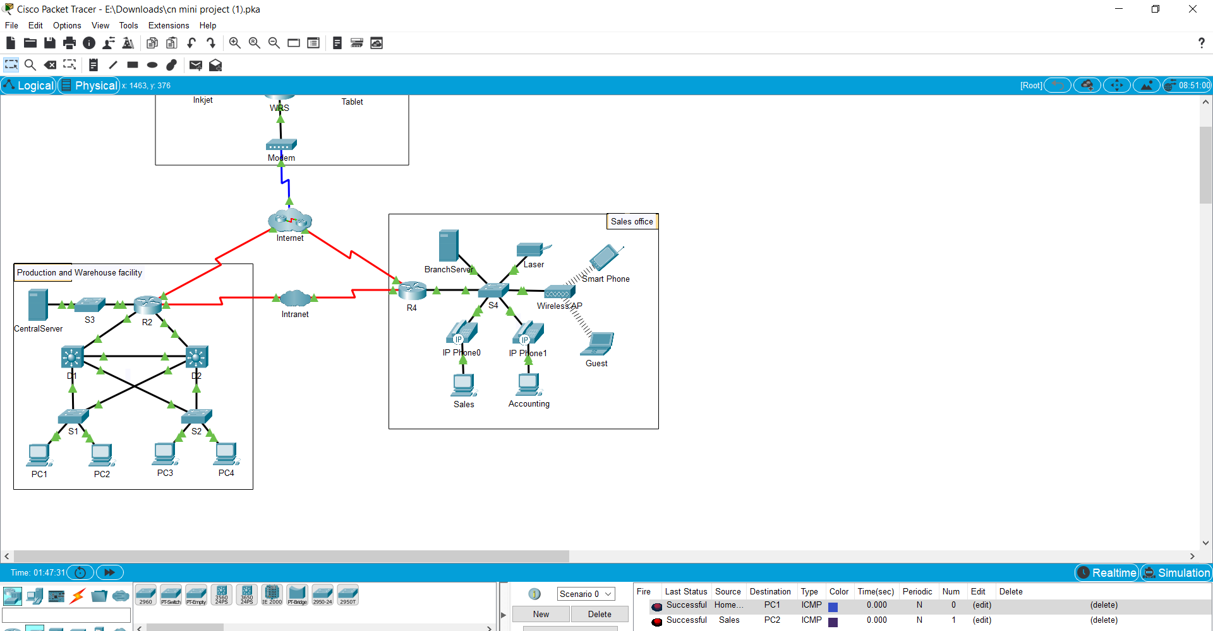



RESULT ANALYSIS

In the above result u can see-

The massage send from sales to pc2 was successful

The message send from home desktop to pc1 was successful

The message send from sales to accounting was successful

As u can see the network is working successfully without any issue and can be used

Commercially.

CONCLUSION & FUTURE WORK

The network for the company is successfully working, massages are sent and received successfully within the network.

FUTURE WORK

In the age of wireless devices, it's easy to forget that the physical locations of your devices matter. It still takes time, even if it's just milliseconds, for data to flow through the cables, or transmit through WiFi.

So one easy benefit from a network map is that it allows you to ensure that you have your access points connecting to the nearest physical switch or router. Over a larger-scale operation, this can provide some immediate speedups.

Keeping good records on your various network devices makes it far easier to resell them when you upgrade, which is a popular way for growing businesses to reduce your hardware spends.

**REFERENCES**

**1** Computer Networks lab manual

2 cisco packet tracer

3 subject faculty

4 internet